Makindu's Next Man Up  SC CA (PRA -N)  Black & White  HP504888/02 (USA)  B: 12 Oct 2015  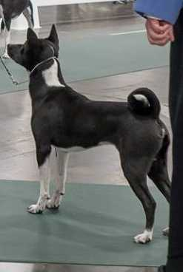 | BISS BIF GCh DC  Emerant Makindu Heez Got Game  BN RI MC LCX NAP CA CL1-F CL1-R GRC SOR ORC RATO TKA (CLd) (PRA -Cr)  Black & White  HP364136/05 (USA)  B: 14 Dec 2009 | GCH BISS AM Ch  Platinum's Fearisnotafactor  RN JC SDHR (pCR)  HP131540/01 (USA) | AM Ch  Berimo Taji Start Me Up  SDHR (pCL)
AM Ch
Klassic's Sweet Patootie
(pCR)
 |  | AM Ch  Emerant N Fopaws Sheza Seeker  RN SC BBHR (CLd) (PRA -Cr)  HP262615/03 (USA) | AM CAN Ch  Fopaws N Bajoran After Hours  JC (pCL)
DC
Zuri's Gracii
SC BBHR (pCR)
 | FC  Avongara Naziki  SC RATN (CLd) (PRA -N)  AV1102 - HP43309901 (Dungu, DR Congo)  B: 2 Nov 2010 | Unknown AV Naziki Sire  (Dungu, DR Congo)
Unknown AV Naziki Dam
(Dungu, DR Congo)
DC, CAN Ch  Emerant's R E S P E C T  SC SWA SCM SIM SEM SHDN (CLd) (PRA -Cr)  Black Tan & White  HP447613/02 (USA)  B: 11 Dec 2012  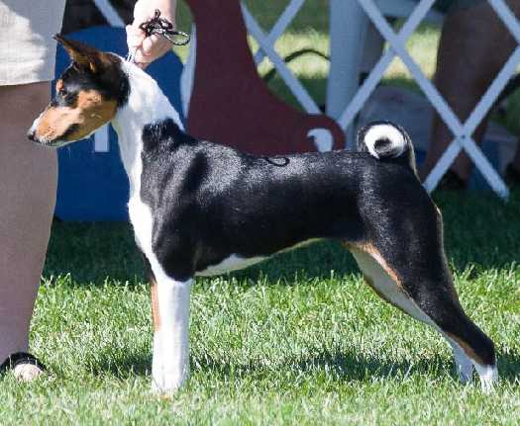 | BISS AM BIS CAN Ch  Emerant's The Instigator  JC CGC SDHR MAOM (pCR)  HM915460/01 (USA)  B: 20 Aug 2000 | AM CAN Ch  Emerant's Flying Fizgig  JC (pAFS)  HM614797/01 (USA) | AM CAN Ch  Vikentor's Stealth Of Emerant  JC
Emerant's Elvira
BBHR (pCR)
 |  | AM Ch  Zuri's Hadiya At Emerant  (pCL)  HM793665/02 (USA) | AM Ch  Jerlin's General Patton  SDHR
AM Ch
Zuri's Okolo
BBHR
 | AM Ch  Platinum's Conspiracy Theory  BBHR (pCL)  HP283204/04 (USA)  B: 30 Nov 2007 | MBISS GCH AM Ch, Can Ch  Emerant's The Navigator  JC MAOM NW1 (pCR)  HP136542/01 (USA) | BISS AM BIS CAN Ch  Emerant's The Instigator  JC CGC SDHR MAOM (pCR)
AM Ch
Sonbar's Graceful Goddess
BBHR (pCL)
 |  | AM Ch  Platinum's Shopping Spree  BBHR (pCL)  HP000753/02 (USA) | AM Ch  Taji's Mel Bourne In The USA  JC
DC
Platinum's Charge It To Taji
SC

